**Name & ID**: Basil khowaja bk08432 **Date:** 24-09-24

|  |
| --- |
| **EE-424L Data Communication & Networking**  **Fall 2024**  **Habib University**  **Dhanani School of Science & Engineering** |

LAB 5: **Configure Switching Lab (VLAN & TRUNK) on Cisco Layer 2 Switches**

|  |  |  |  |  |  |  |  |  |  |  |  |  |  |  |  |  |  |  |  |  |  |  |  |
| --- | --- | --- | --- | --- | --- | --- | --- | --- | --- | --- | --- | --- | --- | --- | --- | --- | --- | --- | --- | --- | --- | --- | --- |
| **Lab #5 Marks distribution:**   |  |  |  |  |  |  | | --- | --- | --- | --- | --- | --- | |  |  | **LR1=30** | **LR5=40** | **LR8=10** | **AR4=20** | | **In-Lab Tasks** | **Task 1** | /15 | /20 | /10 | /20 | | **Task 2** | /15 | /20 | | **Marks Obt.** | **/100** | | | | |  |  |  | | --- | --- | | **objectives** | **The purpose of this lab is to introduce students to Cisco Switches and configure and verify Telnet and VLANs on Cisco Switches.** | |

**In-Lab Tasks:**

|  |
| --- |
| **Task 1: Build and configure a small Network on Cisco Switch 2960 and verify its connectivity** |

**Task 2: Creation and Verification of VLANs in Network**

**Introduction**

**Switch**

Switches are the devices that connect multiple other devices (like PCs, hubs, other switches, routers) to form a network. This device usually has 24 ports with each port having the ability to learn 132 mac addresses this can give you an idea of how accommodating a switch can be. Un- like hub a switch enables multiple ports to communicate with each other this is achieved through hard ware called ASIC (application specific Integrated Circuit). It creates circuits between two ports so that they can communicate without collision with other port traffic. The basic symbol of a switch which is universally used is shown below.

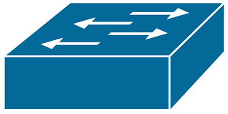

Image of such a real switch is shown below with all its ports that accommodates variety of devices.

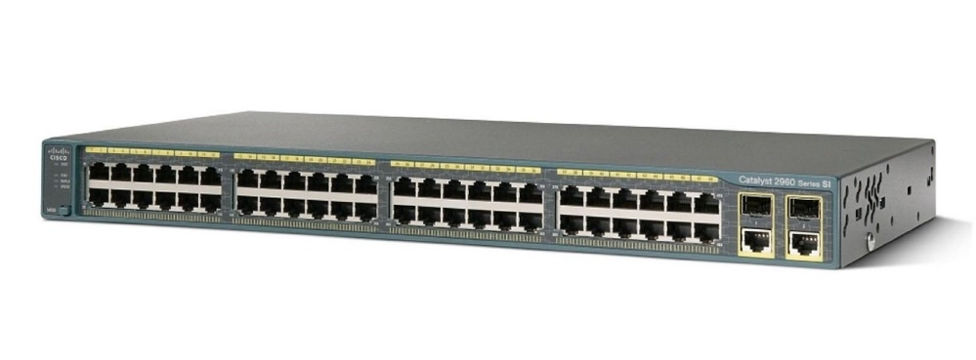

**Configure Cisco Switch 2960**

To program a switch use **Serial or USB** console connection and connect power cord to switch.

**Switch LED Indicators: Performance Monitoring**

Listed below are some of the key LED indicators for the Cisco Catalyst 2960 switch.

1. **SYSTEM (SYST):** Overall status of the switch.

Off: Switch is not powered on

Green: Switch is working fine

Amber: Switch is powered on but faulty

1. **REDUNDANT POWER SUPPLY (RPS):** Provides backup power to the switch if the main supply goes off.

Off: No RPS available,

Green: RPS is working fine

Amber: RPS is faulty

Flashing Amber: RPS is providing backup (primary power off)

Blinking Green: Providing backup to some other device

1. **DUPLEX:** Duplex status of the switch ports.

Off: Switch port is half duplex

Green: Switch port is full duplex

1. **UTIL:** Utilization status of the switch ports.

1. **SPEED:** Speed status of the switch ports.

Off: Switch port is operating at 10Mbps

Green:  Switch port is operating at 100Mbps

Flashing green: Switch port is operating at 1000Mbps

1. **STAT:** Status of the switch ports.

Off: No device connected/port is administratively down.

Green:  Device is connected.

Amber:  Port is blocked by Spanning Tree Protocol

Blinking green: Port is sending/receiving data.

Alternating green amber: Fault in link/Frames experiencing error

**PuTTY**

PuTTY is a versatile terminal program for Windows. It is the most popular free SSH client. It supports [SSH](https://www.ssh.com/ssh/protocol/), [telnet](https://www.ssh.com/ssh/telnet), and raw socket connections with good terminal emulation.

**Telnet**

Telnet is a network protocol that allows a user to communicate with a remote device. It is a virtual terminal protocol used mostly by network administrators to remotely access and manage devices. Administrator can access the device by *telnetting* to the IP address or hostname of a remote device.

To use telnet, you must have a software (Telnet client) installed. On a remote device, a Telnet server must be installed and running. Telnet uses the TCP port 23 by default.

One of the greatest disadvantages of this protocol is that all data, including usernames and passwords, is sent in clear text, which is a potential security risk. This is the main reason why Telnet is rarely used today and is being replaced by a much secure protocol called SSH.

**Task 1: Build and configure a small Network on Cisco Switch 2960 and verify its connectivity**

In this task, we will be building a Local Area Network in a star topology with the help of switch and laptops available in the Linux Lab. The end-devices (your Laptops) will be connected to the switch via the virtual ethernet lines which connect the Floor-Box beneath workstation to the Patch-Panel in the Network Housing.

This task will be done in groups. Each group will be using one switch amongst themselves.

**Step 1:**

Unplug the ethernet cable of your Lab workstation (PC) from the D-Line in the Floor-Box and connect the ethernet cable to the Virtual line (V-Line) of Floor-box.

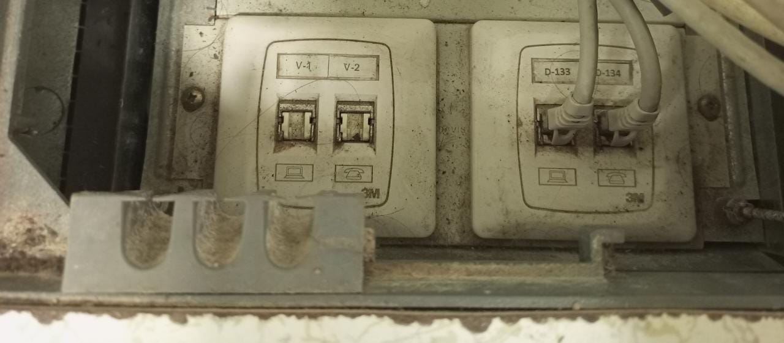

Connect other end of Ethernet cable to your Laptop Rj-45 connector port.

Use the same V-Line as selected above in Cabinet/Rack from Patch panel and connect the patch cord cable from patch panel to your assigned Switch. You can use any available ports of Switch.

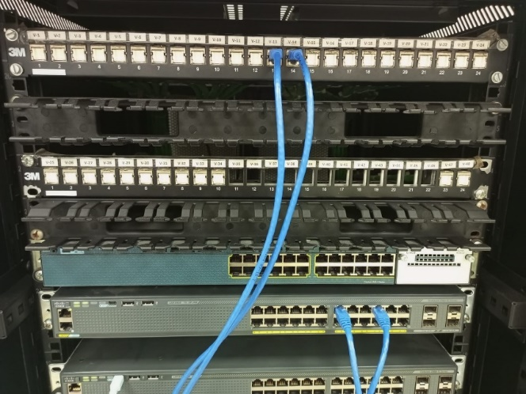

**Step 2:**

Disable your Laptop Wifi.

Open Windows control panel and go to Network Connections.

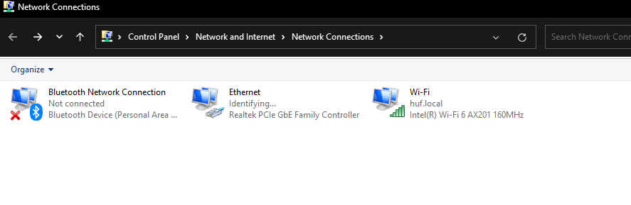

Open ethernet properties and select IPv4 settings. Manually assign static IP address as per Network Address assigned to your group and mentioned in Table below.

put

|  |  |  |  |  |
| --- | --- | --- | --- | --- |
| **Device** | **Student Name** | **IP Address** | **Switch Interface** | **V-Line** |
| **Laptop1** | **Ahmed** | **192.168.10.4** | **Fa0/4** | **v-31** |
| **Laptop2** | **Basil** | **192.168.10.3** | **Fa0/11** | **v-32** |
| **Laptop3** | **abbas** | 192.168.1 0.5 | **Fa0/1** | **v-28** |
| **Laptop4** | **Quddusi** | 192.168.1 0.6 | **Fa0/12** | **v-29** |
| **Laptop5** | **shaheer** | 192.168.1 0.2 | **Fa0/5** | **v-30** |
| **Laptop6** |  |  |  |  |
| **Laptop7** |  |  |  |  |
| **Laptop8** |  |  |  |  |
|  |  |  |  |  |

**Note: Switch-off all the Firewall on laptop before Ping.**

After IPs are assigned to all end-devices of the group, **ping** to one of your peers within a group.

Show and discuss results (attach screenshots):

|  |
| --- |
|  |

**Step 3: Access Cisco Switch Console**

**Note: one student from group ‘ll do this step.**

Connect a USB cable to the Laptop USB port. Connect the other end of the cable to the switch USB console port.

Open PuTTY in your Laptop.

**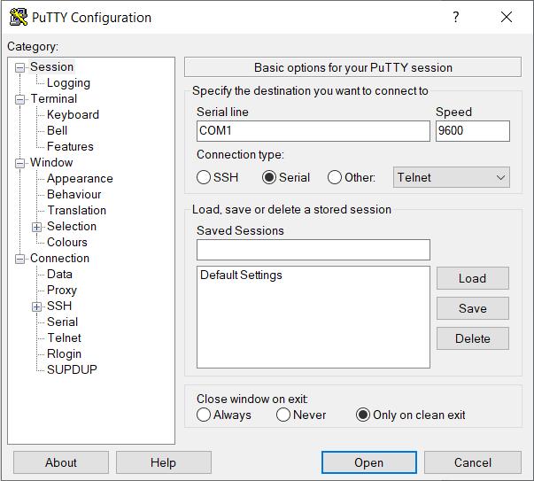**

Select the serial connection type and make sure to enter correct serial number i.e. ‘COM<enter your port number here>’. The speed needs to be 9600 bps.

Note: If you are not sure about the port number, then you can use the windows device manager to find the correct port number.

**Step 4: Configure an IP address on a Switch**

By default, Cisco switches forward Ethernet frames without any configuration. This means that you can buy a Cisco switch, plug in the right cables to connect various devices to the switch, power it on, and the switch will work properly.

However, to perform switch management over the network or use protocols such as SNMP, the switch will need to have an IP address. The IP address is configured under a logical interface, known as the management domain or VLAN. Usually, the default VLAN 1 acts like the switch’s own NIC for connecting into a LAN to send IP packets. Here are the steps to configure an IP address under VLAN 1:

**Note: one student from a group ‘ll do this step**

1. enter the VLAN 1 configuration mode with the*interface vlan 1* global configuration command.
2. assign an IP address with the *ip address IP\_ADDRESS SUBNET\_MASK* interface subcommand.
3. enable the VLAN 1 interface with the *no shutdown* interface subcommand.

Write the commands below to configure an IP to Switch:

|  |
| --- |
| Switch#config  Configuring from terminal, memory, or network [terminal]?  Enter configuration commands, one per line. End with CNTL/Z.  Switch(config)#interface vlan 1  Switch(config-if)#ip address  Jan 4 19:15:46.068: %LINEPROTO-5-UPDOWN: Line protocol on Interface GigabitEthernet1/0/12,  changed state to down  Jan 4 19:15:47.067: %LINK-3-UPDOWN: Interface GigabitEthernet1/0/12, changed stanterface vlan 1  Jan 4 19:15:55.229: %LINK-3-UPDOWN: Interface GigabitEthernet1/0/12, changed state to up  Jan 4 19:15:56.232: %LINEPROTO-5-UPDOWN: Line protocol on Interface GigabitEthernet1/0/12,  changed state to up  Switch(config-if)#ip address 192.168.10.1 255.255.255.0  Switch(config-if)#no shutdown  Switch(config-if)# |

**Note: Switch-off all the Firewall on laptop before Ping.**

Ping from your laptop to one of your peers. Show and discuss results (attach screenshots):

|  |
| --- |
|  |

**Step 5:** Enable Telnet on your switch

Note: one student from a group ‘ll do this step

SW1>**enable**  
SW1#**configure terminal**  
Enter configuration commands, one per line. End with CNTL/Z.  
SW1(config)#**line vty 0 9**  
SW1(config-line)#**password 123**  
SW1(config-line)#**login**  
SW1(config-line)#**logging synchronous**  
SW1(config-line)#**exec-timeout 40**  
SW1(config-line)#**motd-banner**  
SW1(config-line)#**exit**

**SW1(config) # enable password abc**

**Note:**

The “**line vty**” command enable the telnet and the “**0**” is just let a single line or session to the router. If you need more session simultaneously, you must type “**line vty 0 9**”. The “**password**” command set the “**Password**” as password for telnet. You can set your own password. The “**login**” command authenticates and ask you the password of telnet. If you type “**no login**” command, the telnet never authenticate for password which is not a good practice in real network environment. The “**logging synchronous**” command stops any message output from splitting your typing. The “**exec-timeout”** command sets the time-out limit on the line from the default to “**40**”minutes. The **motd-banner** forces a banner message to appear when logging in. In order to control the switch remotely, you must also enable password for it.

**Step 6:**

Now we will be able to access switch remotely and program it accordingly.

Enable the Telnet client for windows in your laptops.

Open windows control panel

Go to Programs and Turn windows features on or off

Select **“TELNET CLIENT”** from the pane and click ok.

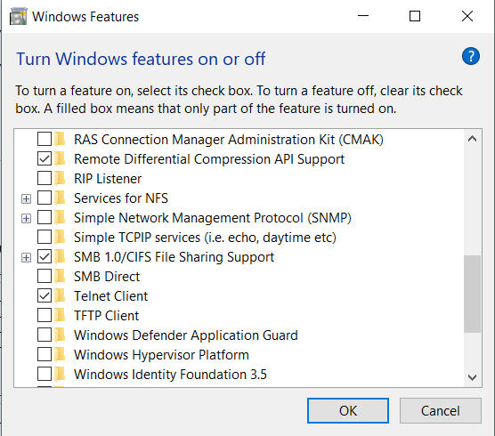Follow the instruction and wait for the program to install.

**Test** telnet connectivity through your laptop and share results (attach screenshots):

PC>**telnet <Switch IP Address>**

|  |
| --- |
|  |

**Task 2: Creation & Verification of VLANs in Network**

This task will be done in groups of 8-9. Each group will be using one switch amongst themselves in continuation of Task 1.

**Note: Any 1 student from group create below VLANs on Switch. First run show vlan brief command to check any previous VLAN and delete if there is any.**

**Step 1:** Initiate a Telnet session with the switch and create 2 VLANs:

* VLAN 10: Student
* VLAN 20: Faculty

Show VLANs and commands (attach screenshots):

|  |
| --- |
| Enter configuration commands, one per line. End with CNTL/Z.  Switch(config)#vlan 20  Switch(config)#name subgroup2  Switch(config)#exit  Switch(config)#vlan 10  Switch(config)#name subgroup1  Switch(config)#exit |

**Step 2: check your interfaces/port number on Switch and become it a part of specific VLAN as per below laptop numbers.**

VLAN 10: Laptop1-Laptop 5

VLAN 20: Laptop6-Laptop 9

Show required commands and VLAN summary (attach screenshots):

|  |
| --- |
|  |

**Ping** the laptop of the peer in your VLAN and in the other VLAN. Check the result to RA.

Discuss and show results (attach screenshots):

|  |
| --- |
| C:\Users\Dell\AppData\Local\Packages\5319275A.WhatsAppDesktop_cv1g1gvanyjgm\TempState\705A72D922ECDC6A54D2EB28B8497FEE\WhatsApp Image 2024-09-24 at 10.32.46_f627e55f.jpg |

The pings from other vlans were not possible and the ones in the same ones we were able to**.**

**Step 3:**

Draw and attach the final network topology for your associated group:

|  |
| --- |
| C:\Users\Dell\AppData\Local\Packages\5319275A.WhatsAppDesktop_cv1g1gvanyjgm\TempState\EE128036D3DADC85597B2C7D729017E4\WhatsApp Image 2024-09-24 at 10.40.36_f8432fcd.jpg |

Note: shaheer had ip address 192.168.10.2 but it was written .7 by mistake

**Step 4:** Remove the patch cord cable from the switch and insert Ethernet cable back to Lab PC and move the RJ-45 Connector from V-Line to D-Line in floor-box.

Make sure to check on **“obtain an IP address automatically” in LAN Ethernet connection settings.**

**Lab Evaluation Assessment Rubric**

**EE-424 Lab 5**

|  |  |  |  |  |  |
| --- | --- | --- | --- | --- | --- |
| **#** | **Assessment Elements** | **Level 1: Unsatisfactory**  **Points 0-1** | **Level 2: Developing**  **Points 2** | **Level 3: Good**  **Points 3** | **Level 4: Exemplary**  **Points 4** |
| **LR1** | **Circuit Layout** | Connections between circuit components are mostly wrong. Circuit layout is cluttered. Needs guidance to make correct equipment/ component connections. | Few of the connections made between circuit components are wrong. Circuit layout is not neat and clean as per standards. | Circuit layout and connections are correct but not all connections are neat and clean as per standards. | Neat, clean and correct connections of all the circuit components/ equipment are made as per standard circuit diagram |
| **LR5** | **Results & Plots** | Figures/ graphs / tables are not developed or are poorly constructed with erroneous results. Titles, captions, units are not mentioned. Data is presented in an obscure manner. | Figures, graphs and tables are drawn but contain errors. Titles, captions, units are not accurate. Data presentation is not too clear. | All figures, graphs, tables are correctly drawn but contain minor errors or some of the details are missing. | Figures / graphs / tables are correctly drawn and appropriate titles/captions and proper units are mentioned. Data presentation is systematic. |
| **LR8** | **Equipment Handling** | Inappropriate handling of the tools and equipment with minimal accuracy. | Appropriate handling of some of the tools and equipment | Appropriate handling of most of the tools and equipment. | Appropriate handling of all the tools and equipment. |
| **AR4** | **\*Report Submission** | Late submission after 1 week and in between 2 weeks. | Late submission after 2 days and within a week. | Late submission after the lab timing and within 2 days of the due date. | Timely submission of the report and in the lab time. |

**\*Report:** Report will not be accepted after 1 week of due date